**1. INTRODUCTION**

* 1. Project Overview
* Before the advent of modern technology, healthcare sector used paper based system to store the medical records, i.e., using handwritten mechanism. This paper-based medical record system was inefficient, insecure, unorganized and was not temper-proof. It also faced the issue of data- duplication and redundancy as all the institutions that patient visited had various copies of patient’s medical records.
* Blockchain have been an interesting research area for a long time and the benefits it provides have been used by a number of various industries. Similarly, the healthcare sector stands to benefit immensely from the blockchain technology due to security, privacy, confidentiality and decentralization. Nevertheless, the Electronic Health Record (EHR) systems face problems regarding data security, integrity and management.
* In this paper, we discuss how the blockchain technology can be used to transform the EHR systems and could be a solution of these issues. We present a framework that could be used for the implementation of blockchain technology in healthcare sector for EHR.
* The EHR systems have been implemented in a number of hospitals around the world due the benefits it provides, mainly the improvement in security and its cost-effectiveness. They are considered a vital part of healthcare sector as it provides much functionality to the healthcare sectors.

1.2 Purpose

* Enhance identity verification processes, reduce the risk of identity theft, and establish a reliable patient identification system across healthcare networks.
* Facilitate efficient and secure sharing of patient information across different healthcare entities, leading to improved collaboration and better-informed medical decisions.
* Empower patients to manage access to their own data, share information selectively, and participate more actively in their healthcare journey.
* Establish transparency and accountability in the management of health data, enabling easy tracking of changes and ensuring the integrity of the information.
* Create a dynamic system that evolves based on user experiences and emerging technologies, ensuring that the blockchain-enabled EHR system remains adaptive and responsive to changing healthcare needs.
* Automate and enforce access control policies, ensuring that only authorized individuals can view or modify specific parts of the health records.
* Improve the efficiency of healthcare operations by eliminating redundant paperwork, minimizing data reconciliation efforts, and providing a unified and standardized system.
* Encourage data sharing by creating a mechanism for patients to benefit from sharing their health information for research or other purposes, contributing to advancements in medical science.
* Ensure a smooth transition for healthcare providers, allowing them to leverage the benefits of blockchain technology without disrupting their current workflows.
* Protect sensitive health information from unauthorized access, tampering, or data breaches, ensuring patient confidentiality and trust.
* Accelerate medical research by providing researchers with access to a diverse and comprehensive dataset, ultimately contributing to the development of new treatments and advancements in healthcare.
* Ensure that the blockchain-enabled EHR system meets regulatory requirements, fostering trust among healthcare providers, patients, and regulatory authorities.
* Enhance the system's ability to recover from data loss or system failures, ensuring continuous access to critical health information even in challenging situations.
* Improve the overall cost-effectiveness of healthcare operations by minimizing paperwork, data reconciliation efforts, and the need for redundant systems, leading to more efficient resource utilization.

**2. LITERATURE SURVEY**

2.1 Existing Problem

The patient may lose control of the existing healthcare data, while the service provider usually maintains the primary stewardship. Patient access permissions to EHRs are very limited, and patients are typically unable to easily share these data with researchers or providers. Interoperability challenges between different providers, hospitals, research institutions, etc. add extra barriers to high-performance data sharing. Without coordinated data management and exchange, the health records are distributed instead of cohesive. Standardization of problem lists in the healthcare industry is needed to enable more efficient exchange of information between health providers and especially to patients. Paper-based structures do not work in electronic environments and some forms of problem list preparation, such as auto-population of lists, represent significant compliance and patient safety concerns.

2.2 References

1]. Health Information and the Law. George Washington University Hirsh Health Law and Policy Program. (Aug. 20, 2015). Who Owns Medical

Records: 50 State Comparison.[Online]..Available: http://www.healthinfolaw.org/comparative-analysis/who-owns-medicalrecords-50-state-

comparison.

[2].K.D.Mandl,P.Szolovits,andI.S.Kohane,‘‘Publicstandardsandpatients’ control: How to keep electronic medical records accessible but private,’’

BMJ, vol. 322, no. 7281, pp. 283–287, Feb. 2001.

[3]. S. Nakamoto. Bitcoin: A Peer-to-Peer Electronic Cash System. Accessed: 2008. [Online]..Available:https://bitcoin.org/bitcoin.pdf

[4]. World Economic Forum. (Sep. 9, 2015). Deep Shift: Technology Tipping Points and Societal Impact. [Online].. Available:

http://www3.weforum.org/docs/WEF_GAC15_Technological_Tipping_Points_report_2015.pdf

[5]. (Dec. 12, 2016). Healthcare Rallies for Blockchains: Keeping Patients at the Center. [Online]..Available: http://www.ibm.biz/blockchainhealth

[6]. M. Swan, Blockchain: Blueprint for a New Economy. Sebastopol, CA, USA: O’Reilly Media, 2015, pp. 53–68.

[7].G.Prisco.(Apr.26,2016).TheBlockchainforHealthcare:GemLaunches Gem Health Network With Philips Blockchain Lab. [Online]..Available:

https://bitcoinmagazine.com/articles/the-blockchain-for-heathcare-gemlaunches-gem-health-network-with-philips-blockchain-lab-1461674938

[8]. U.S. White House. 104th Congress. (Aug. 21, 1996). Public Health Insurance Portability and Accountability Act. [Online]..

Available:https://en.wikipedia.org/wiki/

[9]. P. Taylor. (Apr. 27, 2016). Applying Blockchain Technology to Medicine Traceability. [Online]..Available:

https://www.securingindustry.com/pharmaceuticals/applying-blockchain-technology-to-medicinetraceability

[10].P. B. Nichol. (Mar. 17, 2016). Blockchain Applications for Healthcare: Blockchain Opportunities are Changing Healthcare Globally-Innovative

Leaders See the Change. [Online].. Available: http://www.cio.com/article/3042603/innovation/blockchain-applicationsfor-healthcare.html

[11]. G. Irving and J. Holden, ‘‘How blockchain-timestamped protocols could improve the trustworthiness of medical science,’’ F1000Research, vol.

5, p. 222, May 2016.

[12]. P. Jiang, F. Guo, K. Liang, J. Lai, and Q. Wen, ‘‘Searchain: Blockchainbased private keyword search in decentralized storage,’’ Future Generat.

Comput. Syst., 2017, doi: 10.1016/j.future.2017.08.036.

[13]. X. Liao, J. Yin, S. Guo, X. Li, and A. K. Sangaiah, ‘‘Medical JPEG image steganography based on preserving inter-block dependencies,’’

Computer Electrical Eng.,2017,doi:10.1016/j.compeleceng.2017.08.020.

[14]. H. K. Maji, M. Prabhakaran, and M. Rosulek, ‘‘Attribute-based signatures: Achieving attribute-privacy and collusion-resistance,’’ in Proc.

IACR Cryptol. ePrint Arch., Apr. 2008, pp. 1–23. [Online] Available:https://eprint.iacr.org/2008/328.2.328.

2.3 Problem Statement Definition

The standardization challenge in healthcare problem lists arises from the inadequacy of paper-based structures in the electronic era. Problem lists, essential for conveying patient health issues, lack a unified format, impeding smooth information flow between healthcare providers and hindering patient engagement. The shift to electronic systems introduces complexities, especially with auto-population methods, raising concerns regarding compliance with regulations and compromising patient safety. A comprehensive and standardized approach to problem list management is essential to overcome these obstacles and ensure effective communication, regulatory adherence, and patient-centric care in the digital healthcare landscape.

This problem statement encapsulates the broader paradigm shift in healthcare—moving from traditional, manual processes to a digital ecosystem that demands thoughtful standardization. It underscores the necessity for innovative solutions that not only address current challenges but also lay the foundation for a more interconnected, efficient, and secure future in healthcare information exchange.

In essence, the call for standardization represents a pivotal shift towards more efficient, secure, and patient-centric healthcare information management. Addressing these challenges is fundamental to unlocking the full potential of electronic problem lists, ensuring a seamless exchange of information and upholding the highest standards of compliance and patient safety.

Top of Form

Bottom of Form

**3. IDEATION & PROPOSED SOLUTION**

3.1 Empathy Map Canvas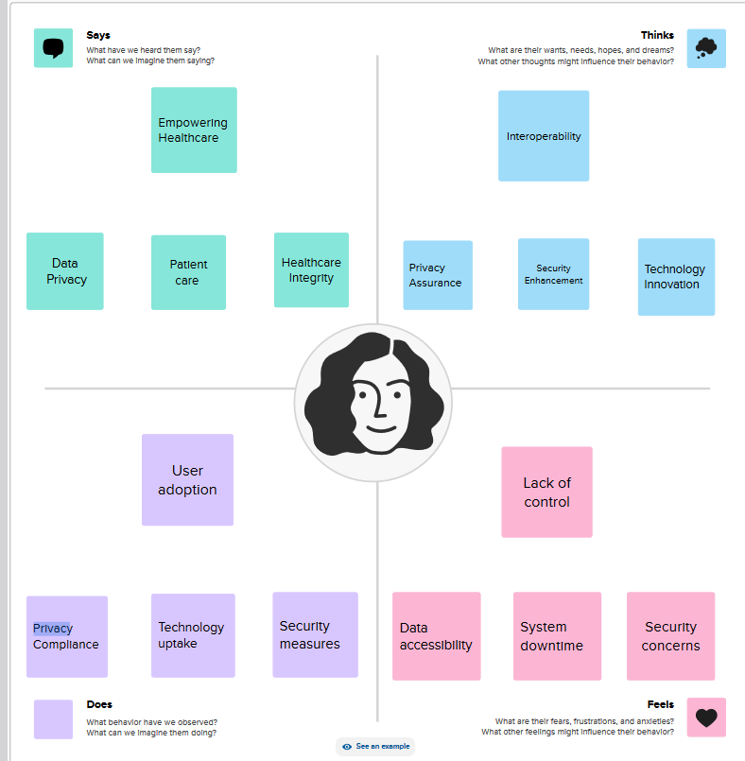

3.2 Ideation & Brainstorming

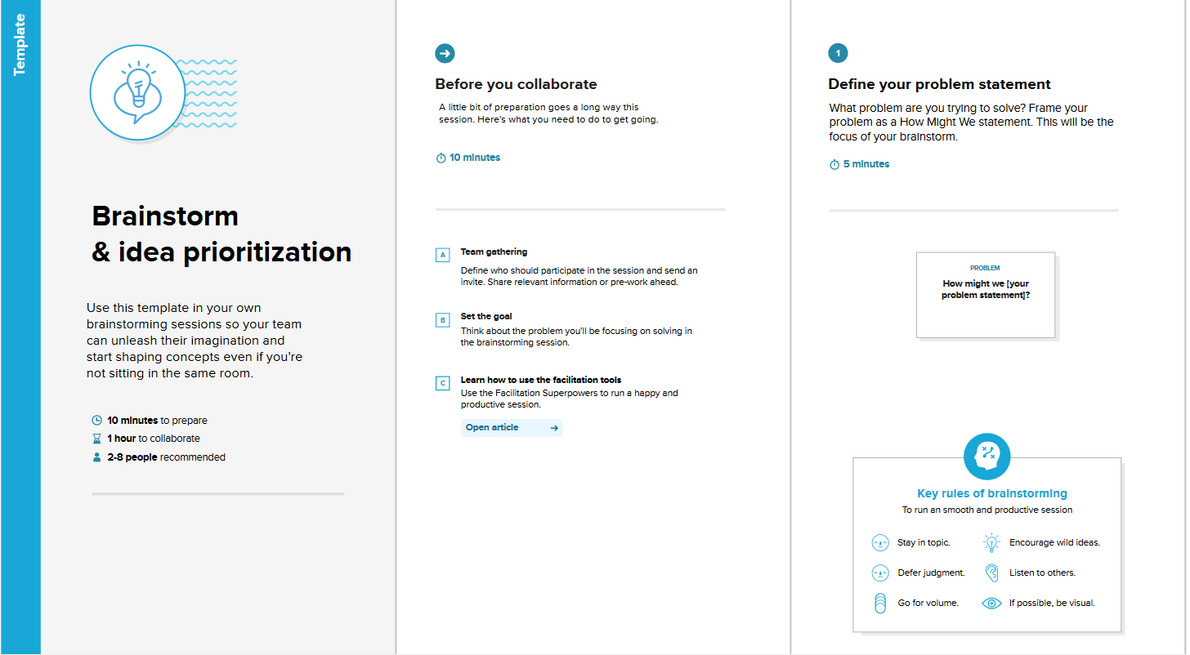

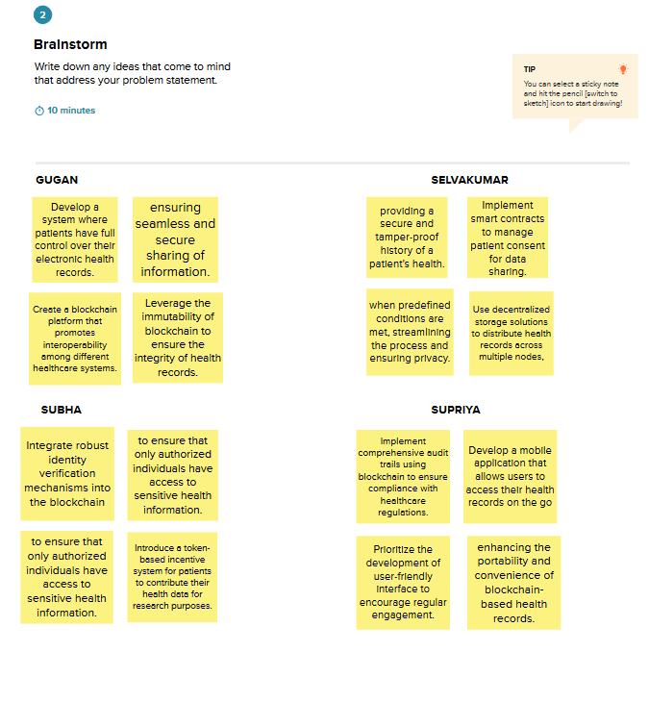

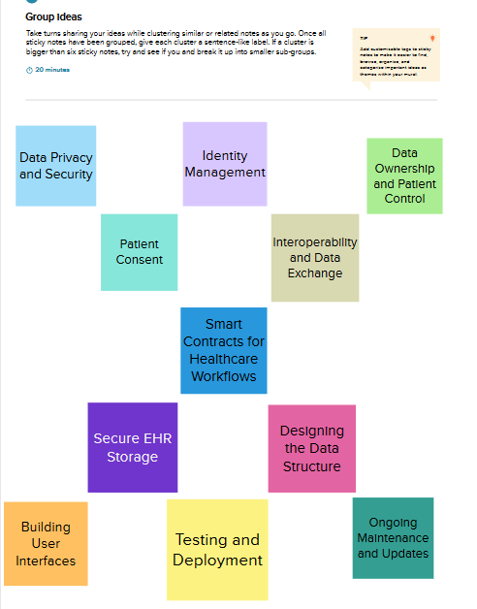

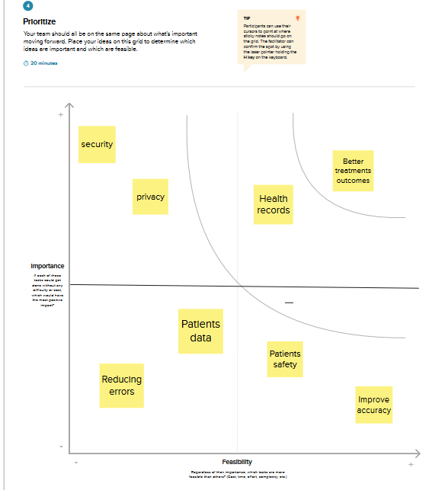

**4. REQUIREMENT ANALYSIS**

4.1 Functional Requirements

1. **User Authentication and Authorization:** Users, including healthcare providers and patients, must undergo secure authentication.

2. **Decentralized Data Storage**: Health records need to be securely stored in a decentralized manner on the blockchain.

3. **Smart Contracts for Access Control:** Implement smart contracts to manage access permissions and data sharing.

4. **Interoperability Standards:** Enable seamless data exchange with other healthcare systems.

5. **Immutable Audit Trail:** Record all transactions and interactions with health records for transparency.

6. **Patient-Controlled Access**: Empower patients to control access to their health record

7. **Security Measures:** Ensure robust security mechanisms to protect against unauthorized access and tampering.

8. **Integration with Existing Systems:** Facilitate smooth integration with legacy healthcare information systems.

9. **Consent Management:** Develop a robust system for managing patient consent.

10. **Real-time Updates:** Allow for real-time updates to health records.

11. **Identity Management:** Ensure secure and reliable patient identity management.

12. **Data Ownership and Monetization:** Enable patients to own and even monetize their health information.

13. **Disaster Recovery Mechanism:** Implement a robust disaster recovery plan for health records.

14. **Educational Interfaces:** Provide educational interfaces for healthcare professionals.

15. **Regulatory Compliance:** Ensure adherence to healthcare regulations and standards.

4.2 Non-functional Requirements

1. **Performance:** The system should support a high transaction throughput to ensure timely access to health records.

2. **Scalability:** The system should scale seamlessly as the number of users and transactions grows.

3. **Reliability:** The EHR system should be highly reliable, with minimal downtime or disruptions.

4. **Availability:** The EHR system should be available 24/7 to ensure continuous access to health records.

5. **Security:** The system should prioritize the security and confidentiality of patient health information.

6. **Compliance:** The EHR system should comply with relevant healthcare regulations and data protection laws.

7. **Usability:** The user interfaces should be intuitive, user-friendly, and accessible to healthcare professionals and patients.

8. **Interoperability:** The system should seamlessly integrate with other healthcare information systems.

9. **Maintainability:** The EHR system should be easy to maintain and update.

10. **Auditability:** The system should provide comprehensive audit trails for all interactions with health records.

11. **Ethical Considerations:** The system should adhere to ethical principles in handling patient data.

12. **Resource Efficiency:** The system should use resources efficiently to minimize operational costs.

13. **Cross-Border Compatibility:** The system should consider compatibility with healthcare regulations across different geographical regions.

14. **Environmental Impact:** The project should consider and minimize the environmental impact, especially regarding energy consumption.

15. **Training and Support:** Provide adequate training and support for users transitioning to the new system.

**5. PROJECT DESIGN**

5.1 Data Flow Diagrams & User Stories

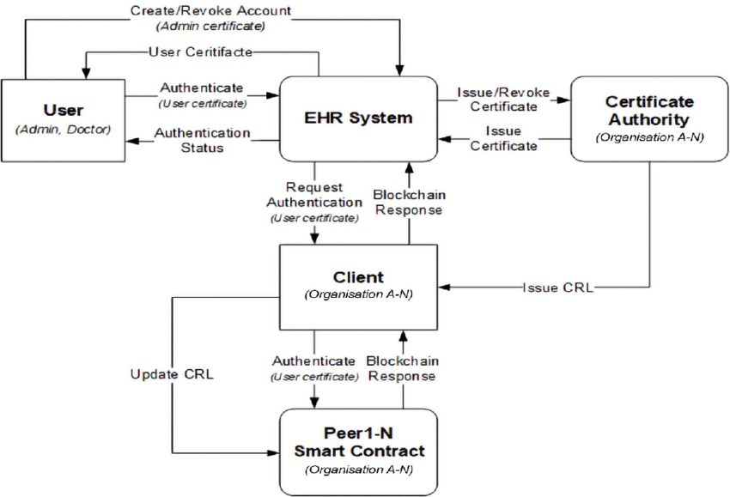

5.2 Solution Architecture

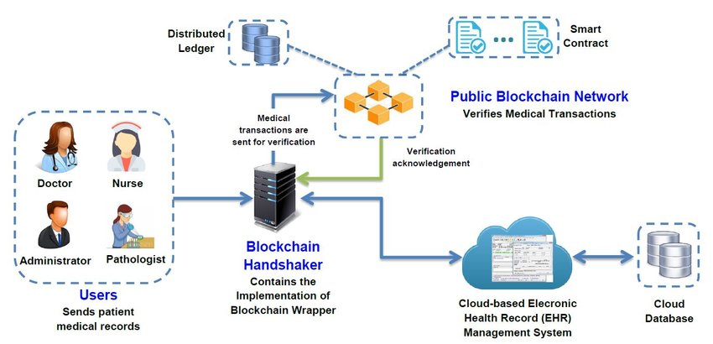

**6. PROJECT PLANNING & SCHEDULING**

6.1 Technical Architecture

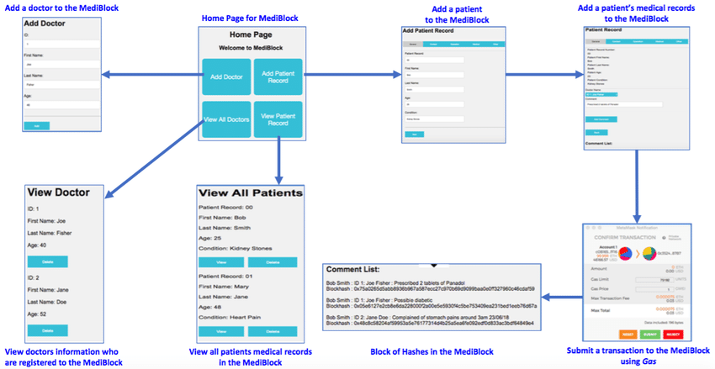

6.2 Sprint Planning & Estimation

1. **Product Backlog Creation**: Start by creating a product backlog, which is a prioritized list of features, user stories, and tasks that need to be completed for the project. The product backlog should include all the requirements for developing an EHR system using blockchain technology.
2. **User Story Refinement**: Break down the high-level requirements into smaller, more manageable user stories. Each user story should represent a specific functionality or feature of the EHR system. Collaborate with stakeholders, including healthcare professionals and blockchain experts, to ensure that the user stories are well-defined and aligned with the project goals.
3. **Estimation**: Assign relative effort estimates to each user story. There are several techniques for estimation, such as story points, t-shirt sizing, or planning poker. Use whichever method works best for your team. The estimation should take into account factors like complexity, dependencies, and risks associated with implementing blockchain technology in the EHR system.
4. **Sprint Planning**: Select a set of user stories from the product backlog to be implemented in the upcoming sprint. Consider the team's capacity and velocity (the amount of work the team can complete in a sprint) when deciding how many user stories to include. Break down the user stories into smaller tasks, if necessary, to facilitate better planning and tracking.
5. **Prioritization**: Arrange the selected user stories in the order of their priority. Consider the value they bring to the users and stakeholders, as well as any dependencies between stories. This prioritization will guide the development team during the sprint.
6. **Sprint Goal**: Define a clear goal for the sprint that aligns with the project objectives. The goal should describe what the team aims to achieve by the end of the sprint, such as completing specific user stories or delivering specific functionality.
7. **Task Allocation**: Assign tasks to team members based on their skills and expertise. Ensure that the workload is distributed evenly and that each team member understands their responsibilities.
8. **Sprint Duration**: Determine the length of the sprint. Common sprint durations are two weeks or four weeks, but you can choose a duration that suits your team's capacity and the project's needs.
9. **Sprint Review and Retrospective**: At the end of the sprint, conduct a review to demonstrate the completed work to stakeholders and gather feedback. Additionally, hold a retrospective meeting to reflect on the sprint process and identify areas for improvement in future sprints.

6.3 Sprint Delivery Schedule

Sprint 1:

Sprint Goal: Establish the basic infrastructure for the EHR system

User Stories/Features:

1. User registration and authentication
2. Basic patient profile creation
3. Blockchain network setup and integration
4. Data encryption and privacy features

Sprint 2:

Sprint Goal: Implement core EHR functionality

User Stories/Features:

1. Patient record creation and management
2. Secure data sharing between healthcare providers
3. Audit trail implementation using blockchain
4. User access control and permissions

Sprint 3:

Sprint Goal: Enhance EHR system usability and interoperability

User Stories/Features:

1. User-friendly interface design improvements
2. Integration with external systems (e.g., laboratories, pharmacies)
3. Data standardization and interoperability enhancements
4. Support for medical imaging and attachments

Sprint 4:

Sprint Goal: Strengthen security and compliance features

1. Enhanced data privacy and consent management
2. Blockchain-based identity management
3. Encryption and access control improvements
4. Compliance with relevant healthcare regulations (e.g., HIPAA)

Sprint 5:

Sprint Goal: Performance optimization and testing

User Stories/Features:

1. Performance tuning and optimization
2. Load testing and stress testing
3. Bug fixing and issue resolution
4. Documentation and knowledge transfer

**7. CODING & SOLUTIONING**

7.1 Feature 1

Blockchain's decentralized and tamper-resistant nature can be harnessed to maintain the integrity of electronic health records (EHRs). Each transaction or update to the EHR can be recorded as a block in the blockchain, creating an immutable and transparent history of the patient's medical data. This ensures that once data is entered into the system, it cannot be altered or deleted without leaving a clear trace. This feature not only enhances security but also builds trust in the accuracy of the health records. Smart contracts can be implemented to define who has permission to access specific parts of a patient's record. This ensures that only authorized individuals, such as healthcare providers and the patients themselves, can view and modify relevant information. The decentralized nature of blockchain also reduces the risk of a single point of failure and unauthorized access, enhancing overall data security and privacy. the use of cryptographic techniques in blockchain can further protect the confidentiality of health records. Patients can have private keys that grant them control over who gets access to their data. This empowers individuals to share their health information selectively, improving privacy and putting patients in control of their own data.

7.2 Feature 2

Blockchain can facilitate seamless and secure sharing of health records across different healthcare providers and systems. Traditional EHR systems often face challenges in interoperability, making it difficult to exchange information between different institutions. With a blockchain-based solution, a patient's comprehensive health history can be securely shared and updated in real-time across various healthcare organizations. This not only streamlines the exchange of information but also ensures data consistency and accuracy. Certainly! Let's consider interoperability. Blockchain can facilitate seamless and secure sharing of health records across different healthcare providers and systems. Traditional EHR systems often face challenges in interoperability, making it difficult to exchange information between different institutions. With a blockchain-based solution, a patient's comprehensive health history can be securely shared and updated in real-time across various healthcare organizations. This not only streamlines the exchange of information but also ensures data consistency and accuracy.

Moreover, the use of a standardized blockchain protocol can serve as a common language for different EHR systems, promoting interoperability and compatibility. This can be particularly beneficial in emergency situations where quick access to accurate patient information from various sources can be crucial for making informed medical decisions.

7.3 Database Schema

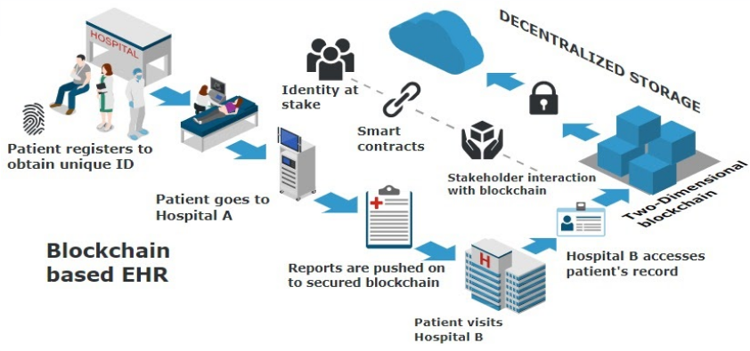

**8. PERFORMANCE TESTING**

8.1 Performance Metrics

The performance metrics to focus on:

1. **Transaction Throughput:**
   * Measure the number of transactions processed per second. This is crucial to ensure that the system can handle the required load, especially in healthcare where timely access to patient records is critical.
2. **Latency:**
   * Evaluate the time it takes for a transaction to be recorded and validated on the blockchain. Low latency is essential for real-time access to health records.
3. **Scalability:**
   * Assess the system's ability to scale with increasing data and user load. Ensure that the blockchain network can handle the growing volume of healthcare transactions.
4. **Consensus Mechanism Performance:**
   * Depending on the blockchain protocol used, analyze the efficiency of the consensus mechanism (e.g., proof-of-work, proof-of-stake). This includes confirmation times and resource requirements.
5. **Data Integrity and Immutability:**
   * Verify that once data is recorded on the blockchain, it remains unchanged and secure. The immutability of health records is a critical aspect of maintaining data integrity.
6. **Security:**
   * Evaluate the overall security of the blockchain network. This includes resistance to tampering, encryption strength, and protection against unauthorized access.
7. **Interoperability:**
   * Measure the system's ability to integrate with existing healthcare IT infrastructure and standards. Ensure that it can seamlessly exchange data with other healthcare systems.
8. **Compliance:**
   * Check if the system complies with relevant healthcare regulations and privacy standards (e.g., HIPAA). Non-compliance can lead to legal issues and compromise patient privacy.
9. **Resource Utilization:**
   * Monitor the utilization of computing resources (CPU, memory, storage) to ensure optimal performance and cost-effectiveness.
10. **Fault Tolerance and Recovery:**
    * Assess the system's ability to recover from failures or attacks. This includes testing disaster recovery mechanisms and backup processes.
11. **User Experience:**
    * Collect feedback on the user experience, especially in terms of accessing and updating health records. A user-friendly interface is crucial for adoption.
12. **Cost Efficiency:**
    * Analyze the overall cost of implementing and maintaining the blockchain-based EHR system. Ensure that it provides value for the invested resources.

**9. RESULTS**

9.1 Output Screenshots

### [Home Page](https://github.com/yashverma9/AI-Blockchain-Electronic-Health-Records-Management-System#1-home-page)



### [Patient Home](https://github.com/yashverma9/AI-Blockchain-Electronic-Health-Records-Management-System#2-patient-home)



### [Doctor asking for permission from patient](https://github.com/yashverma9/AI-Blockchain-Electronic-Health-Records-Management-System#3-doctor-asking-for-permission-from-patient)



### [Patient grants permission to the doctor for the specific report](https://github.com/yashverma9/AI-Blockchain-Electronic-Health-Records-Management-System#4-patient-grants-permission-to-the-doctor-for-the-specific-report)



# Doctor-Downloads-Report



**10. ADVANTAGES & DISADVANTAGES**

Advantages

1. **Security and Data Integrity:** Blockchain's decentralized and immutable ledger enhances the security and integrity of health records.
2. **Interoperability:** Blockchain facilitates seamless data exchange and interoperability between different healthcare systems.
3. **Decentralization:** Elimination of a central authority reduces the risk of a single point of failure.
4. **Patient-Centric Control:** Patients gain control and ownership of their health records through private keys.
5. **Efficient and Transparent Data Management:** Reduced administrative overhead and transparent data management processes.
6. **Enhanced Identity Management:** Blockchain can contribute to secure patient identity management.
7. **Adaptability to Emerging Technologies:** Blockchain-enabled EHR systems can adapt to emerging technologies and standards.

**8. Public Trust and Transparency:** The decentralized and transparent nature of blockchain technology builds public trust.

Disadvantages

1. **Scalability Challenges:** Some blockchain networks may face scalability issues as the number of transactions increases.
2. **Integration Complexity:** Integrating blockchain with existing EHR systems can be complex and resource-intensive.
3. **Lack of Standardization:** The absence of standardized data formats and coding systems across healthcare organizations.
4. **Privacy Concerns:** While blockchain enhances security, the immutability of the ledger raises privacy concerns.
5. **Smart Contract Risks:** Bugs or vulnerabilities in smart contracts could pose risks to data security.
6. **Complexity in Governance:** Establishing governance models for blockchain networks in healthcare can be challenging.
7. **Educational Barriers:** Healthcare professionals may face a learning curve in adapting to blockchain-based EHR systems.
8. **Unintended Consequences:** Implementation of blockchain may lead to unintended consequences or unforeseen challenges.

**11. CONCLUSION**

* EHR is the digital record of the medical history of the patient. It has solved many issues related to data handling and its security. This paper has reviewed the various EHR requirements, issues with EHR systems, and use of blockchain to resolve these issues.
* The potential to provide a decentralized, secure, and interoperable platform for managing health records is substantial. The adoption of blockchain can lead to improved patient outcomes, streamlined processes, and advancements in medical research.
* To realize these benefits, it is crucial to prioritize thorough planning, stakeholder education, and ongoing adaptation to emerging technologies and regulatory landscapes. Ultimately, a well-executed project of EHR using blockchain technology has the potential to reshape the healthcare industry, fostering trust, transparency, and innovation in the management of critical health information.
* The patient-centric approach, enabled by blockchain's features like patient-controlled access and consent management, marks a significant step toward empowering individuals in managing their health information. This not only aligns with the principles of data ownership and privacy but also fosters a collaborative relationship between healthcare providers and patients.
* Continuous collaboration with regulatory bodies, ongoing monitoring of emerging technologies, and a commitment to ethical considerations will be essential in navigating the evolving landscape of healthcare regulations and standards. As the project progresses, feedback from users, including healthcare professionals and patients, should be actively solicited to refine and enhance the system's usability and effectiveness.
* In essence, the project's success lies not only in the technological advancements it brings but also in the strategic navigation of challenges and the continuous commitment to improving healthcare outcomes
* The journey toward blockchain-enabled electronic health records represents a significant leap forward, promising a future where healthcare data is secure, accessible, and contributes to advancements in patient care and medical research.
* Furthermore, as the project unfolds, attention to non-functional requirements, such as scalability, energy efficiency, and interoperability, will be pivotal in ensuring the system's reliability and sustainability. Overcoming the initial challenges of integration with existing systems and addressing potential resistance to change among healthcare professionals are integral aspects of a successful implementation.
* In conclusion, the implementation of electronic health records (EHR) using blockchain technology holds great promise in revolutionizing healthcare data management. The advantages, including enhanced security, interoperability, patient empowerment, and transparent data management, signify a transformative shift toward a more efficient and patient-centric healthcare ecosystem. However, challenges such as scalability, integration complexities, and regulatory uncertainties must be carefully addressed.

**12. FUTURE SCOPE**

**1.Advanced Data Analytics:** Integration of artificial intelligence (AI) and machine learning (ML) with blockchain-enabled EHR systems for advanced data analytics.

**2.Internet of Things (IoT) Integration:** Connecting IoT devices to the blockchain for real-time monitoring and data collection.

**3**. **Blockchain Interoperability:** Development of standards for interoperability between different blockchain networks in healthcare.

**4. Patient-Centric Health Platforms:**  Development of comprehensive patient-centric health platforms powered by blockchain.

**5**. **Secure Telemedicine Ecosystems:** Integration of blockchain in telemedicine platforms for secure and transparent health data exchange.

**6**. **Continued Research and Innovation:** Ongoing research and innovation in blockchain technology for healthcare.

**7**. **Decentralized Clinical Trials:** Implementation of decentralized and blockchain-based clinical trial platforms.

**8**. **Integration with Emerging Technologies:** Integration with emerging technologies such as quantum computing for enhanced security and processing capabilities.

**13.APPENDIX**

**A. Glossary of Terms**

1. **Blockchain:** A distributed and decentralized digital ledger that records transactions across a network of computers in a secure, transparent, and tamper-resistant manner.
2. **EHR (Electronic Health Record):** A digital version of a patient's paper chart, containing medical history, diagnoses, medications, treatment plans, immunization dates, allergies, radiology images, and laboratory test results.
3. **Smart Contracts:** Self-executing contracts with the terms of the agreement directly written into code. In the context of healthcare, smart contracts can automate processes such as access control and consent management.
4. **Interoperability:** The ability of different information systems, devices, or applications to connect, communicate, and exchange data seamlessly.
5. **Consensus Mechanism:** The process by which nodes in a blockchain network agree on the state of the blockchain. Common mechanisms include Proof of Work (PoW) and Proof of Stake (PoS).
6. **FHIR (Fast Healthcare Interoperability Resources):** A standard for healthcare data exchange, enabling interoperability between different health information systems.

**B.Project Timeline**

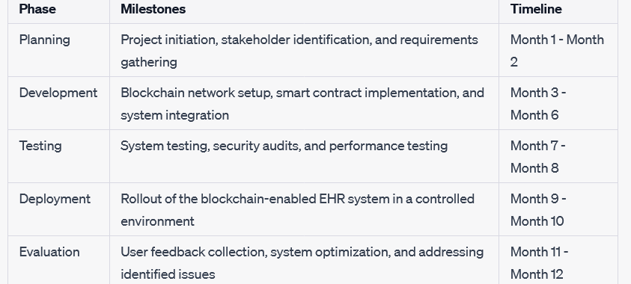

**C. Regulatory Compliance Checklist**

1. **HIPAA (Health Insurance Portability and Accountability Act):**

Implementation of encryption and access controls to ensure the confidentiality of patient information.

1. **GDPR (General Data Protection Regulation):**

Mechanisms in place for obtaining and managing patient consent transparently.

1. **HITECH Act:**

Regular security audits and updates to comply with HITECH Act requirements.

**D. Technical Specifications**

1. **Blockchain Network:** Description of the chosen blockchain platform (e.g., Ethereum, Hyperledg Details of the consensus mechanism implemented.
2. **Smart Contracts:** Overview of the implemented smart contracts and their functions.
3. **Data Encryption:** Encryption algorithms used to protect patient data.

**E. User Guides**

1. **Healthcare Providers:** Instructions for accessing and managing patient health records. Guidelines for utilizing smart contracts for access control.
2. **Patients:** Step-by-step guide on accessing and managing personal health records

Information on how to control access permissions using private keys.

**F. References**

1. K. N. Griggs, O. Ossipova, C. P. Kohlios, A. N. Baccarini, E. A. Howson et al., “Healthcare blockchain system using smart contracts for secure automated remote patient monitoring,” Journal of Medical Systems, vol. 42, no. 7, pp. 130, 2018.

2. G. G. Dagher, J. Mohler, M. Milojkovic and P. B. Marella, “Ancile: Privacy-preserving framework for access control and interoperability of electronic health records using blockchain technology,” Sustainable Cities and Society, vol. 39, pp. 283–297, 2018.

3. T. Alshalali, K. M’Bale and D. Josyula, “Security and privacy of electronic health records sharing using hyperledger fabric,” in 2018 Int. Conf. on Computational Science and Computational Intelligence, Las Vegas, NV, USA, pp. 760–763, 2018.

|  |
| --- |
|  |